Malawi Global Financing Facility for Every Woman and Every Child

Country Platform

Terms of Reference
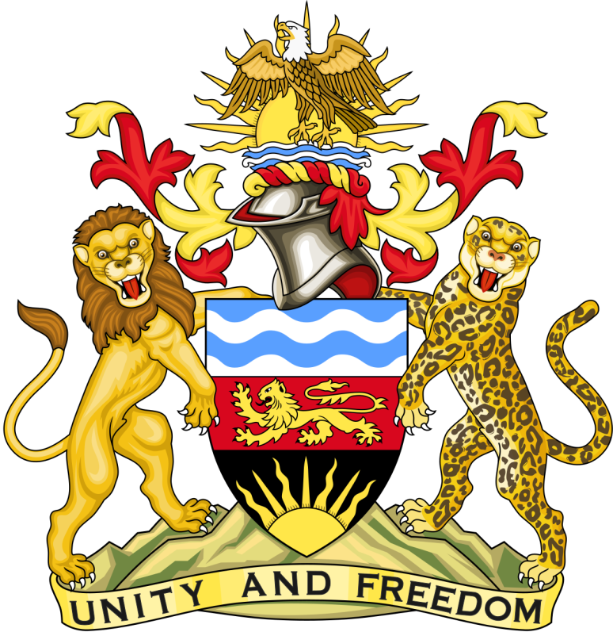
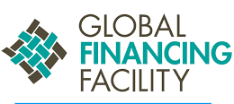

Contents

Introduction 3
Country Platform: Health Sector Working Group 3
The Guiding Principles 5
Country Platform Roles 6
Constituent Members and Roles 7
Outputs 9
Reporting 9
Annex 10

Introduction
Multi-stakeholder country platforms are considered key to successful implementation of the Global Strategy. The Country Platform will play a central role in developing, implementing and monitoring the Investment Case and health financing strategy. Established under the leadership of national government, the platform will be inclusive and transparent and maximize the comparative advantage of a broad range of partners.
The role of the Country Platform is to set strategic direction for the national approach to RMNCAH and nutrition investments and financing, help prioritize investments for funding, provide policy and technical support, enhance communication among stakeholders, ensure complementary financing and strengthen collaboration among government ministries. The platform also enhances coordination of stakeholders (particularly private sector and civil society) and oversees the implementation of the investment case through a robust results framework.
In order to accomplish its role, the Malawi Country Platform will engage a wide range of stakeholders. Leveraging an extensive analysis of existing platforms, government and partners agreed that the GFF Country Platform will be Health Sector Working Group (HSWG). The group represents the governance platform for coordinating health sector-wide reforms and can coordinate tasks requiring multi-sectoral engagement.
The Platform is made of specific constituencies such as government ministries and agencies, development partners (multi- and bilateral), funding mechanisms and foundations, civil society (including media, faith based organizations, and accountability structures), international and local NGOs, private sector, professional associations, academic and research institutions, and youth organizations (Figure 1).
These Terms of Reference provide guidance on the specific roles and responsibilities of the Country Platform and its constituent members for the development and implementation of the investment case.
MoH
Government
MDAs
Development Partners
Funding Mechanisms/ Foundations
INGOs/NGOs
Private sector
Professional Associations
CSOs/Councils/FBOs/Media
Academia/ Research Institutions
Secretariat DPPD

Treasury

Figure 1: Malawi GFF Country Platform

Country Platform: Health Sector Working Group
The Ministry of Health (MoH) coordinates the health sector based on the six health system building blocks: Leadership and Governance, Health Financing, Human Resources for Health, Service Delivery, Health Information/M&E, and Supply Chain. The Health Sector Working Group represents the Leadership and Governance building block, responsible for technical guidance on health sector reforms before presentation to higher levels of decision making within and outside the Ministry.
Specific technical working groups on Service Delivery, Health Financing, Supply Chain Management, Health Information Management/Monitoring and Evaluation, Human Resources for Health and their sub-TWGs report to the HSWG on a regular basis. Specifically, the Health Financing TWG is currently working on the health financing strategy relevant for the development of the investment case.

Operationalization of the Country Platform involves:
- Quarterly review of progress by the Health Sector Working Group as the Country Platform
  - The Health Sector Working Group will engage other ministries to ensure an inclusive representation of stakeholders for the GFF process
- Implementation of the GFF work plan by the GFF task force and regular reporting to the Country Platform (See Annex for the Task Force ToRs and Members)
- Recruitment of the GFF Coordinators who will focus on the development and implementation of the investment case. The GFF task force will support the coordinators on the execution of their tasks as necessary. The Coordinators will report to the Head of the Department of Planning and Policy Development.

Figure 2: Schema of HSWG and TWGs
 | HSS Building Block | TWG |  | Sub-TWG/Task Force
 | Leadership and Governance | Health Sector Working Group |  | Health Donors Group
 |  |  |  | HIV/AIDS Donors Group
 |  |  |  | Joint Harmonization Group
 |  |  |  | District Administration Working Group
 | Health Financing | Health Financing TWG |  | Health Financing Strategy Task Force
 |  |  |  | Performance-based Financing Task Force
 | Human Resource for Health | Human Resource for Health TWG |  | HRH TWG
 | Service Delivery | Service Delivery TWG |  | Quality Management TWG
 |  |  |  | EHP TWG
 |  |  |  | Community Health TWG
 |  |  |  | Reproductive Health TWG
 |  |  |  | Hospital Autonomy Task Force
 |  |  |  | Decentralization Task Force
 |  |  |  | Key Populations TWG
 |  |  |  | Prevention Task Force
 |  |  |  | ART/PMTCT
 |  |  |  | Diagnostics TWG
 | Health Information/M & E | Monitoring and Evaluation TWG
 | Supply Chain | Supply Chain TWG |  | Medical Products
 |  |  |  | Infrastructure and Equipment
The GFF Country Platform will maintain continued engagement with the GFF constituencies and existing platforms such as the Global Fund Country Coordinating Mechanism, PMNCH Multi-stakeholder and GMT RMNCAH+N advocacy platforms and District Harmonization Forum.

The Guiding Principles

- Country Leadership: the Global Financing Facility promotes country ownership and coordination of the process including development and implementation of the investment case in line with aid effectiveness principles.
- Inclusiveness: The Country Platform is inclusive, involving constituents from government, development partners, funding mechanisms, civil society organizations and non-governmental organizations, private sector, professional associations and academic institutions. The platform should reflect the interests of policy makers, implementers and communities.
- Transparency: The platform encourages timely access to information on progress on development and implementation of the investment case. These include relevant documents, reports and minutes of meetings from the platform and other structures within the health system and wider country context that are related to the Global Financing Facility. This helps to promote mutual understanding and continued commitment towards achieving its goals and targets.
- Mutual Accountability: the platform promotes joint planning and monitoring of implementation of the roadmap and investment case. It ensures members take responsibilities for and deliver on specific tasks based on their capabilities and the process effectively aligns with existing monitoring mechanisms hinged on existing strategies and policies including the Malawi Growth and Development Strategy III, Health Sector Strategic Plan II, Health Financing Strategy, Quality Management Strategy, and Sexual and Reproductive Health Strategy.

Country Platform Roles

- Strategic Direction: The platform provides strategic direction for the national approach to RMNCAH, Nutrition investments, and financing. The platform takes specific technical and policy decisions in the implementation of the roadmap, development and implementation of the investment case.

- Advocacy and Stakeholder Engagement: The platform will ensure effective advocacy for the implementation of the investment based on an extensive stakeholder engagement strategy.

- Inter-Sectoral Collaboration and Partners Coordination: The platform coordinates activities of constituents and facilitates effective communication with development partners, civil societies, private sector, academic institutions, and communities.

- Resource Mobilization: The platform will facilitate resource availability particularly complementary financing from domestic and external sources for the implementation of the roadmap, and development /implementation of the investment case.

- Capacity Strengthening: The platform will play a key role in identifying technical assistance gaps and facilitate means to bridge these gaps to sustain progress on the implementation and monitoring of the investment case. Engaging with academic institutions can enhance institutionalizing capacity strengthening for the GFF process.

- Monitoring, Evaluation, Accountability and Learning: the platform will develop and implement a results framework, to guide monitoring of the implementation of the investment case. This will include realistic targets that leverage existing national strategies and implementation modalities within a decentralized health system.

Constituent Members and Roles
This section lists the key constituencies, their members, and their roles and responsibilities.

Constituency | Proposed Members | Roles And Responsibilities | Representative in Country Platform
Government | - Office of the President and Cabinet  - Ministry of Health and Population  - Ministry of Finance/Treasury  - Ministry of Education, Science, and Technology  - Ministry of Gender, Disability and Social Welfare  - Ministry of Agriculture, Irrigation, and Water Development  - Ministry of Local Government and Rural Development  - Ministry of Youth  - Ministry of Home Affairs and Internal Security  - National Registration Bureau  - National Youth Council  - National Planning Commission  - National Statistics Office (NSO)  - Parliamentary Representative and Councils  - Representatives of Districts Councils | - Leadership and stewardship including convening all stakeholders to develop investment case and health financing strategies in support of RMNCAH and nutrition.  - Ensures that progress on roadmap and investment case implementation aligns with guiding principles  - Provide enabling environment for effective domestic and external resource mobilization | All members listed
Development Partners | - UN Agencies: WHO, UNICEF, UNFPA, UN Women, UNDP, UNAIDS  - Multilaterals: World Bank, EU  - Bilaterals: USAID, DFID, GIZ/KfW, Irish Aid, SIDA, JICA, NORAD, Embassy of Iceland | - Global, regional and country-level coordinated policy, technical and financial assistance.  - Fosters cross-country sharing of knowledge, best practices and experience on what works  - Convenes multi-sectoral partners around RMNCAH, building on and reinforcing existing mechanisms for coordination | Health Donors Group Chair and Co-Chair
Funding Mechanism/  Foundations | - GAVI, the Vaccine Alliance  - The Global Fund  - Bill and Melinda Gates Foundation  - Health Sector Joint Fund | - Alignment of funding  - Complementary financing (increasingly over time through pooling or shared management) of an agreed investment case  - Aligning ongoing investments in broader technical assistance and service delivery programs with the agreed investment case  - Adherence to aid effectiveness principles such as transparency and predictability  - Sharing of global good practices
INGOs/NGOs | - Health Policy Plus  - Clinton Health Access Initiative  - Management Sciences for Health  - Baobab Health Trust  - World Vision International  - RTI International  - Catholic Relief Services  - Partners In Health  - Care International  - Options  - Data for Health Initiative  - Save the Children  - JHPIEGO  - Plan International  - Chemonics International  - FHI | - Support country planning and implementation, including development of investment case and health financing strategies  - Service delivery and demand generation,  - Advocacy for resource mobilization and policies  - Independent monitoring and accountability to strengthen national and sub-national responses  - Advocacy and social mobilization to ensure accountability and strengthen national and sub-national responses | Technical Assistance Partners – Health Policy Plus, CHAI, Options, MSH
CSOs/FBOs/Media  /Accountability Structures | - Malawi Health Equity Network  - Universal Health Coverage Coalition  - Civil Society Organization Nutrition Alliance  - Family Planning Association of Malawi  - Malawi Coalition of Basic Education  - CISANET  - Maikhanda Trust  - National Youth Network  - Health and Rights Education Programme  - Malawi Interfaith AIDS Organization  - Malawi Girl Guides Association  - Malawi Human Rights Commission  - Medical Council of Malawi  - Nurses and Midwives Council of Malawi  - Pharmacy, Medicine and Poisons Board  - Malawi Economic Justice Network  - Parent and Child Health Initiative  - Office of the Ombudsman  - DREAMS (20 organizations) | - Amplifying voices of local communities to identify needs, barriers, and bottlenecks;  - Support country planning and implementation, including development of investment case and health financing strategies  - Advocacy for resource mobilization and policies and social mobilization to ensure accountability and strengthen national and sub-national responses  - Independent monitoring and accountability to strengthen national and sub-national responses; support for tracking and transparency of financial flows  - Enhancing communication and transparency with large and diverse network of civil society and with communities | Malawi Health Equity Network, CSONA, Family Planning Association of Malawi, Malawi Coalition of Basic Education, National Youth Network
Private Sector | - Christian Health Association of Malawi  - Private Hospitals/Practitioners  - MASM  - Malawi Chamber of Commerce and Industry  - Pharmaceutical Companies | - Service delivery strengthening, manufacturing, commodity distribution, etc. including through public private partnerships  - Providing human resource for health through private health training institutions  - Leveraging new technologies to improve and strengthen RMNCAH services | Christian Health Association of Malawi
Health Professional Associations | - Medical Association of Malawi (Specialists, Clinical officers)  - National Organization of Nurses and Midwives of Malawi  - Association of Malawian Midwives  - Pharmaceutical Society of Malawi  - Laboratory Association of Malawi | - Adaptation and compliance with standards and guidelines  - Voicing health workforce challenges and developing effective strategies to address them | Medical Association of Malawi (Specialists, Clinical officers)  National Organization of Nurses and Midwives of Malawi
Academic and Research Institutions | - University of Malawi (College of Medicine, College of Nursing, School of Public Health, Centre for Social Research)  - Malawi University of Science and Technology  - Johns Hopkins University  - Health Economic Unit Thanzi La ONSE- University of York  - Liverpool School of Tropical Medicine  - London School of Hygiene and Tropical Medicine  - University of North Carolina  - REACH Trust | - Producing and distilling evidence for policymaking and priority setting  - Institutionalize knowledge management platform for the development and implementation of investment case | College of Medicine – University of Malawi

Outputs
The key outputs for the country platform are:
- GFF Roadmap
- Investment Case
- Health Financing Strategy
- Monitoring Reports on the IC and HFS

Reporting
The Technical Working Groups work on specific tasks related to the development and implementation of the investment case and health financing strategy. They report to the Health Sector Working Group through the GFF Task Force.
Minutes of meetings and reports of progress of the country platform are made available by the GFF coordinators and supporting core team to constituent members via available communication channels building on an accessible knowledge management platform including but not limited to Google Drive.
This term of reference may be reviewed from time to time to accommodate the dynamic context of the multi-stakeholder platform.

Annex

Terms of Reference for the Global Financing Facility Task Force

Introduction: The Global Financing Facility process requires the formation of the Country Platform and a task force. While the Platform provides strategic oversight, the task force works on the operationalization of the process particularly the development of the investment case.
Key Activity: The Taskforce will be in charge of driving progress on the development of the GFF investment case under the oversight of the Country Platform.
Secretariat: It is coordinated by the Department of Planning and Policy Development.
Deliverables: Its specific deliverables include:
- Development of GFF investment case roadmap
- Stakeholder mapping for the GFF country platform
- GFF Launch
- GFF Investment case
  - Situation and bottleneck analysis
  - Prioritization of interventions
  - Development of monitoring and evaluation framework
  - Costing and financial gap analysis for the investment case
- Health financing strategy
  - Facilitate development of the health financing strategy
Meeting: The task force will meet at least once a month.
Membership: These include personnel with technical and administrative skills relevant for the GFF process. They include:
- Government of Malawi
  - Ministry of Health
    - Department of Planning and Policy Development
    - Reproductive Health Directorate
    - Quality Management Department
    - Community Health Services Section
  - Ministry of Finance – Treasury
  - Ministry of Agriculture
  - Ministry of Education
  - Ministry of Gender
  - Ministry of Youth
- Development Partners
  - WHO
  - UNICEF
  - UNFPA
  - World Bank
  - Options
  - Health Policy Plus
  - Clinton Health Access Initiative
- Civil Society/NGOs
  - Maikhanda Trust
  - Malawi Health Equity Network
  - Civil Society Organization Nutrition Alliance
  - National Youth Network

