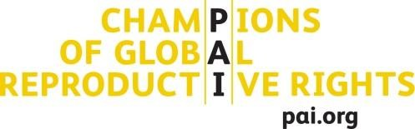

Snapshot: malawi CSO gff coalition-building meeting

Malawi joined the GFF in November 2017. Malawi is using the existing Health Sector Working Group as the GFF Country Platform. A GFF Taskforce of the Health Sector Working Group is spearheading the development of the country investment case, under the leadership of the Department of Planning. Civil Society Organizations (CSOs) MHEN, CSONA, Maikhanda are represented on the Health Sector Working Group and GFF Taskforce, thus indicating early CSO engagement in the GFF process.

To foster early participation and engagement of Malawian CSOs in the GFF process, PAI on behalf of the global Civil Society Coordinating Group on the GFF (CSCG) , supported an interim Malawi CSO GFF Platform leadership team to host a national GFF CSO workshop in Lilongwe-Malawi, July 23rd to 25th. The meeting objectives were to:
- Map the GFF processes in Malawi and opportunities for CSO engagement
- Create a unified, effective CSO GFF platform in Malawi
- Develop a CSO an advocacy action plan, and/or joint communication strategy for civil society engagement in GFF.

The meeting was attended by 35-40 people, mainly CSOs from local organizations. There was also representation from international partners, such as Oxfam and Amref. Participants included a senior official from the Malawi Ministry of Health and Planning, 3 resource persons from the global CSCG (Suzanna Dennis/PAI, Susannah Hurd/Global Health visions and Maty Dia/independent consultant).

Meeting Outcomes:
During the meeting, participants developed the organogram of their coalition and elected a leadership structure: A steering committee composed of the existing members of the GFF Taskforce plus the two new additions to the GFF Taskforce: Oxfam and AECDM. Participants elected MANASO as the Secretariat of the coalition, to support the Steering Committee and maintain momentum. If this coalition sustains its drive, it will be the first advocacy focused health coalition that is independent of any one organization or project. The healthy presence of youth organizations will hopefully sustain the group’s energy.

As the coalition started developing advocacy objectives, it became clear that they would need more time and support to develop their GFF Action Plan. While a few organizations in Malawi are strong on advocacy, capacity tends to be limited.

As next steps, the coalition will develop a Terms of Reference defining roles and responsibilities, develop a GFF Action Plan defining the coalitions priorities, and identify resources to sustain engagement in GFF. The coalition will mobilize financial and technical resources internally, but external support will likely also be required.

